**CSS INTERVIEW QUESTION’S**

**1. What is CSS?**

The full form of CSS is Cascading Style Sheets. It is a styling language which is simple enough for [HTML](https://career.guru99.com/top-50-html-interview-questions/) elements. It is popular in web designing, and its application is common in XHTML also.

### 2. What is the origin of CSS?

Standard Generalized Markup Language marked the beginning of style sheets in 1980s.

**3. What are the different variations of CSS ?**

**The variations for CSS are:**

* CSS 1
* CSS 2
* CSS 2.1
* CSS 3
* CSS 4

**4. What are the limitations of CSS ?**

**Limitations are:**

* Ascending by selectors is not possible
* Limitations of vertical control
* No expressions
* No column declaration
* Pseudo-class not controlled by dynamic behavior
* Rules, styles, targeting specific text not possible

**5. What are the advantages of CSS ?**

**Advantages are:**

* Bandwidth
* Site-wide consistency
* Page reformatting
* Accessibility
* Content separated from presentation

### 6. What are CSS frameworks?

It is a pre-planned libraries, which allows easier and more standards-compliant webpage styling, using CSS language.

### 7. Who maintains the CSS specifications?

World Wide Web Consortium maintains the CSS specifications.

**8. In how many ways can a CSS be integrated as a web page?**

CSS can be integrated in three ways:

* Inline: Style attribute can be used to have CSS applied HTML elements.
* Embedded: The Head element can have a Style element within which the code can be placed.
* Linked/ Imported: CSS can be placed in an external file and linked via link element.

**9. What benefits and demerits do External Style Sheets have?**

Benefits:

* One file can be used to control multiple documents having different styles.
* Multiple HTML elements can have many documents, which can have classes.
* To group styles in composite situations, methods as selector and grouping are used.

Demerits:

* Extra download is needed to import documents having style information.
* To render the document, the external style sheet should be loaded.
* Not practical for small style definitions.

**10. Discuss the merits and demerits of Embedded Style Sheets?**

Merits of Embedded Style Sheets:

* Multiple tag types can be created in a single document.
* Styles, in complex situations, can be applied by using Selector and Grouping methods.
* Extra download is unnecessary.

Demerits of Embedded Style Sheets:

* Multiple documents cannot be controlled.

### 11.Differentiate Style Sheet concept from HTML?

While HTML provides easy structure method, it lacks styling, unlike Style sheets. Moreover, style sheets have better browser capabilities and formatting options.

### 12.What is contextual selector?

Selector used to select special occurrences of an element is called contextual selector. A space separates the individual selectors. Only the last element of the pattern is addressed in this kind of selector. For e.g.: TD P TEXT {color: blue}.

### 13.Compare Grouping and Nesting in CSS?

Grouping:  Selectors can be grouped having the same values of property and the code be reduced.

### 14.How can backward compatibility be designed in CSS?

HTML sheet methods is collaborated with CSS and used accordingly.

### 15.Why is @import only at the top?

@import is preferred only at the top, to avoid any overriding rules. Generally, ranking order is followed in most programming languages such as Java, Modula, etc. In C, the # is a prominent example of a @import being at the top.

### 16.Which among the following is more precedent: CSS properties or HTML procedures?

CSS is more precedent over HTML procedures. Browsers, which do not have CSS support, display HTML attributes.

### 17.What is Inline style?

The Inline style in a CSS is used to add up styling to individual HTML elements.

### 18.How comments can be added in CSS?

The comments in CSS can be added with /* and */.

### 19.Define Attribute Selector?

It is defined by a set of elements, value and its parts.

### 20.Define property?

A style, that helps in influencing CSS. E.g. FONT. They have corresponding values or properties within them, like FONT has different style like bold, italic etc.

### 21.What is Alternate Style Sheet?

Alternate Style Sheets allows the user to select the style in which the page is displayed using the view>page style menu. Through Alternate Style Sheet, user can see a multiple version of the page on their needs and preferences.

### 22.Are quotes mandatory in URL’s?

Quotes are optional in URLs, and it can be single or double.

**23.Cascading?**

* The term "cascading" refers to the way CSS applies styles. Styles can be defined in multiple places: within the HTML itself, in external stylesheets, or in the browser's default styles.
* The "cascade" determines which styles are applied when there are conflicts. CSS uses a set of rules to decide the order of priority, which is known as the "cascade". This involves considering the specificity, source order, and importance (e.g., !important declarations).

**24.Specificity in CSS?**

Specificity is a mechanism in CSS that determines which styles are applied to an element when multiple rules could apply. It is essentially a measure of the importance of a CSS selector. When there are conflicting styles, the styles with higher specificity take precedence.

**25.** **what is the default value of position property?**

The default value of the position property in CSS is static. When an element's position property is set to static, it is positioned according to the normal flow of the document.

**26. what is the difference between relative and absolute position?**

* When an element is set to position: relative;, it is positioned relative to its normal position in the document flow.
* It moves from its default position based on the top, right, bottom, and left properties.
* Other elements around it still occupy the original space it would have taken up.
* When an element is set to position: absolute;, it is positioned relative to its nearest positioned ancestor (an ancestor element that is itself position: relative;, position: absolute;, or position: fixed;).
* If no positioned ancestor is found, it positions itself relative to the initial containing block (usually the <html> element).
* Absolute positioning takes the element out of the normal document flow, meaning it does not leave a space for it in the page layout.

**27.what is box model in CSS?**

The **Box Model** in CSS is a fundamental concept that describes the structure of every HTML element on a web page. It consists of four main parts that constitute the space an element occupies and how it is rendered (Content,Border,Padding and Margin).

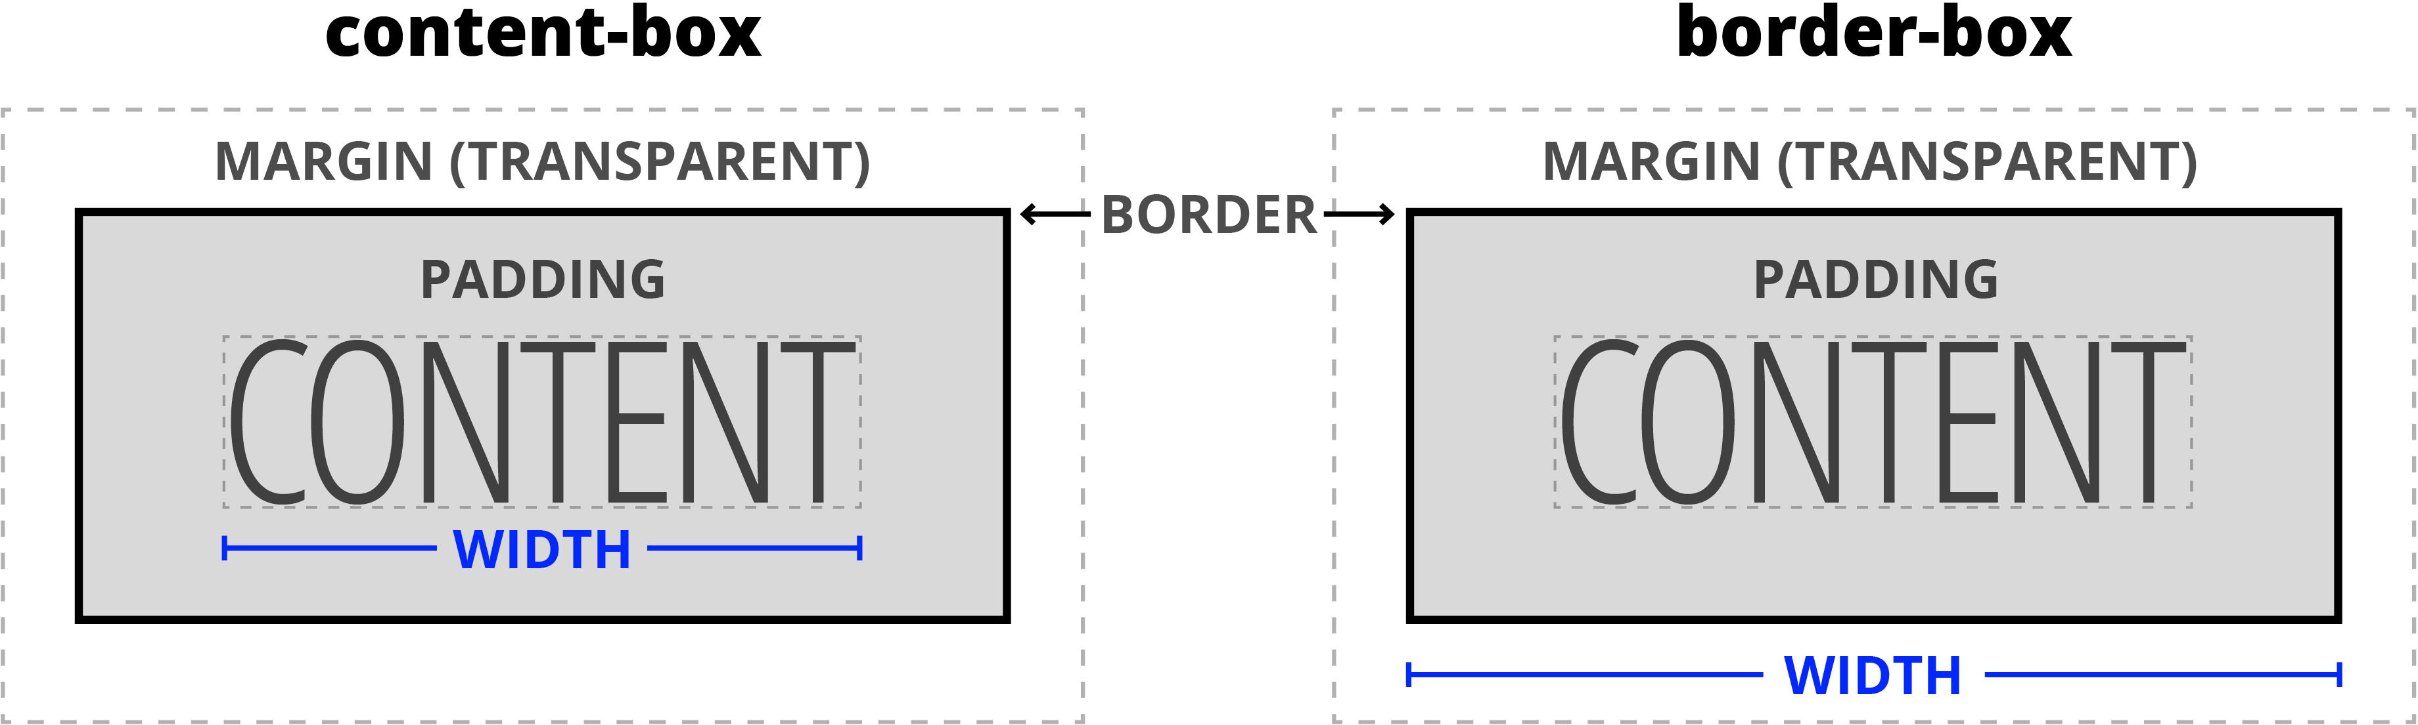**28.** **what is the difference between box border**  **and content box?**

************************